EXPERIMENT 18:

S4 class – student information

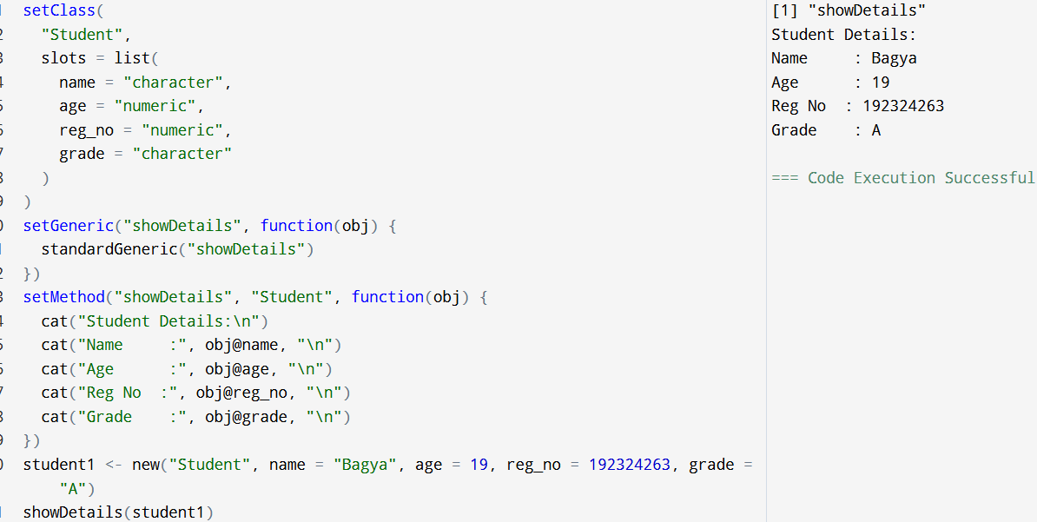

EXPERIMENT 19:

DATA FRAME FOR EMPLOYEE NAME, SALARY AND DESIGNATION.

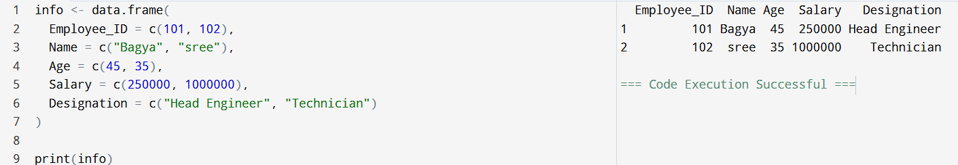

EXPERIMENT 20:

DATAFRAME FOR PAYROLE SYSTEM.

